My class MainGame consists of all aspects of the game.

It has the operations and the driver.

The game starts off with the main beginning screen which asks the user to enter in his/her name.

Main screen is done by scene paint_main_screen, and called in the start method.

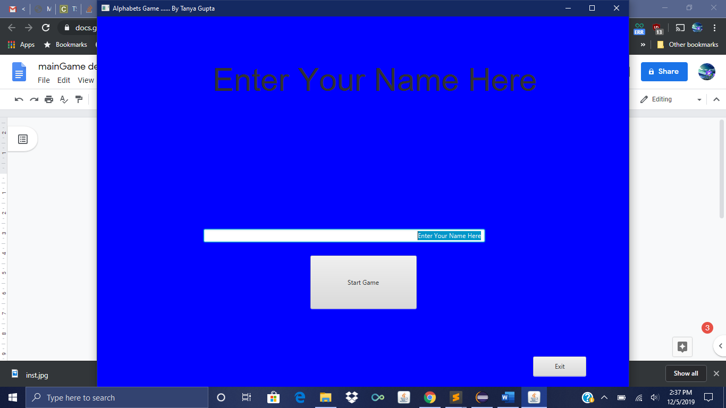

Upon pressing start, startbutton is invoked and sets out the action.

It then uses paint_game_screen, and shows the first question with directions.

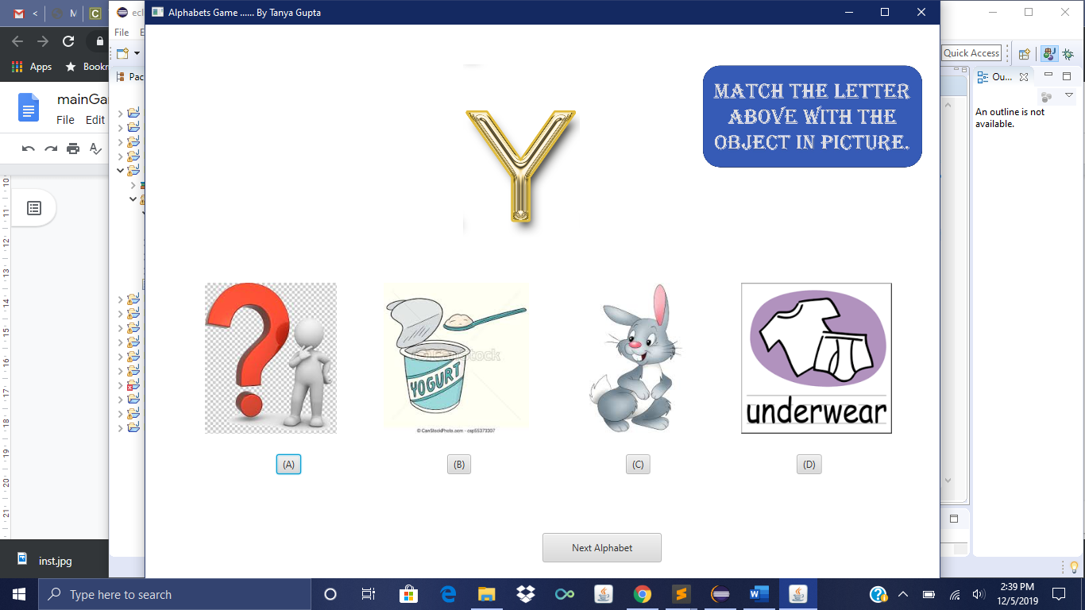

After answering the question, if it is right, then a happy Simpsons picture will show up.

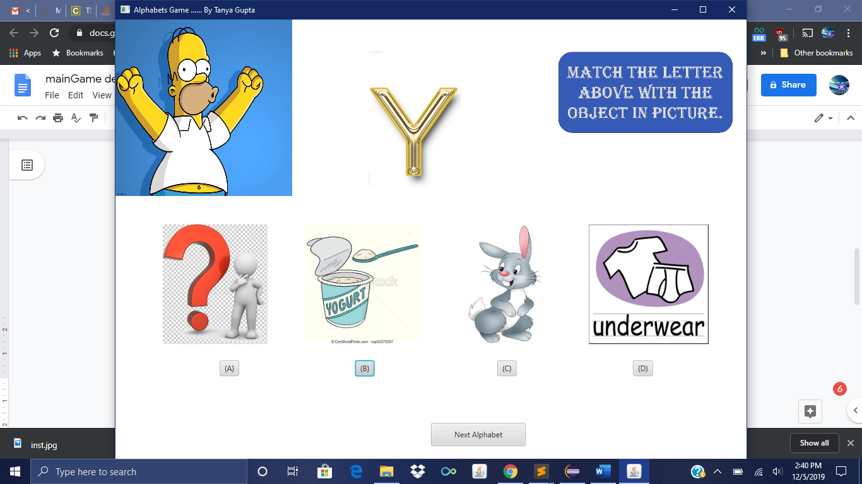

If wrong, then a frustrated Simpsons pic will show up.

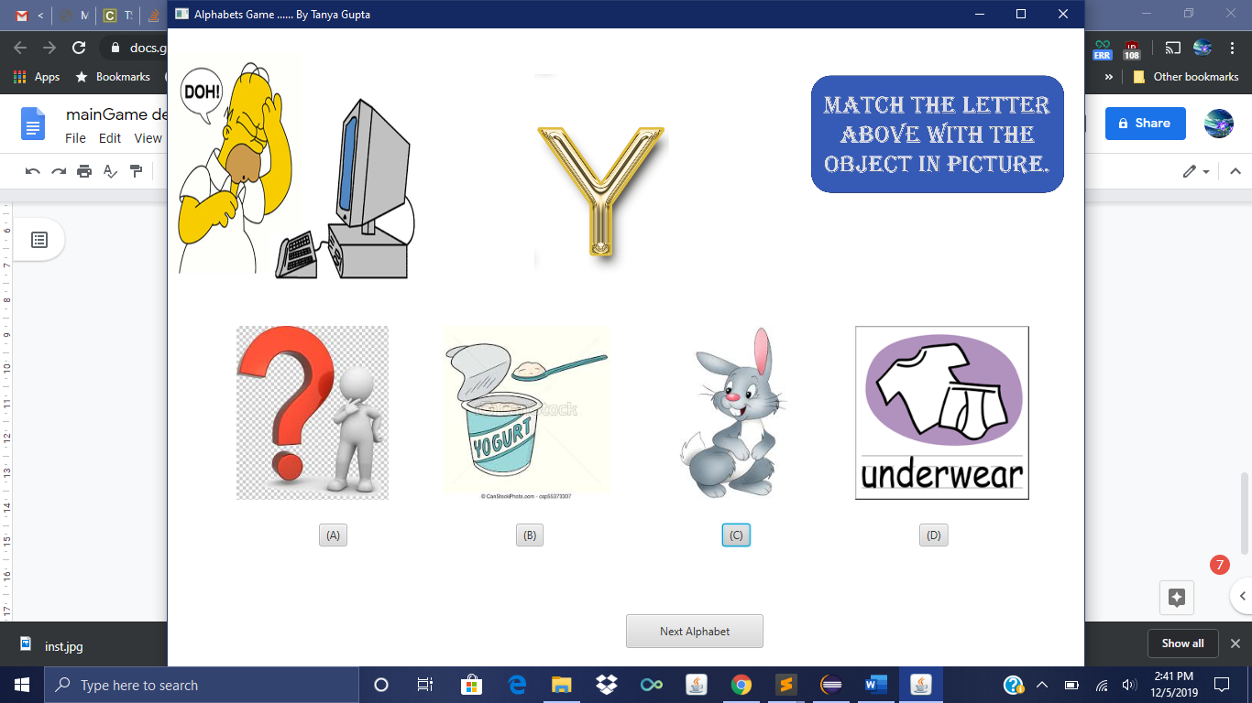

Upon pressing next, the screen will go to the next question 4 more times.

The method paint_next_screen will be used here.

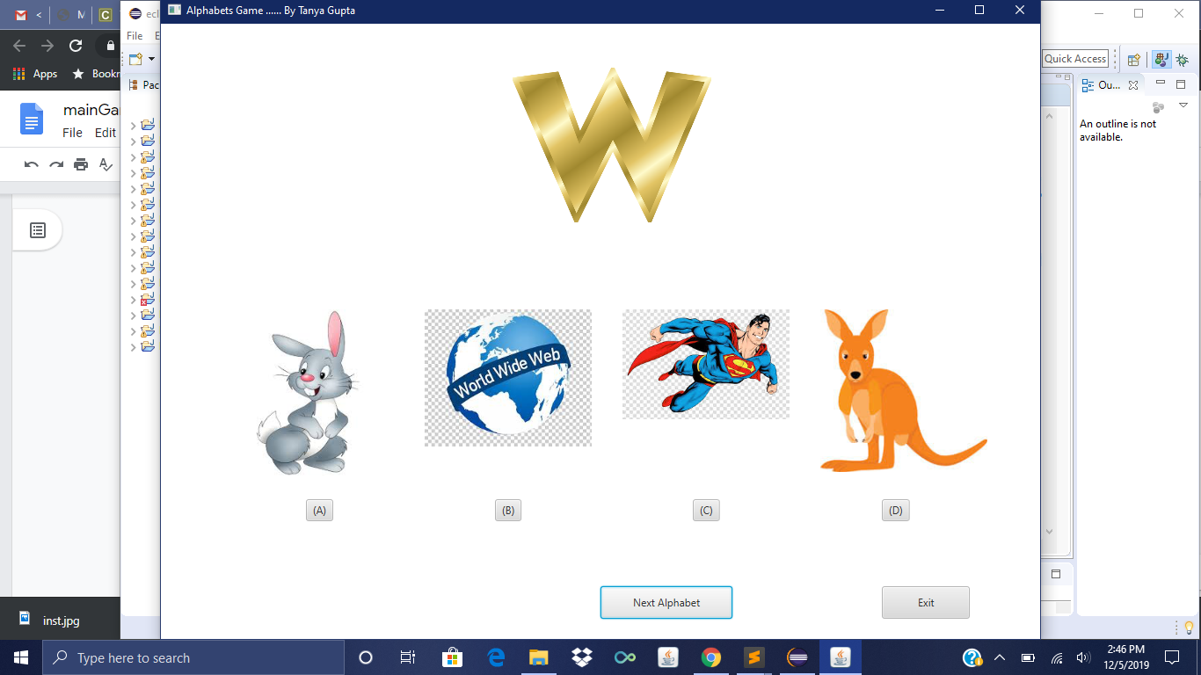

At all times the user can exit the program using the exit button.

This is will terminate the program.

The last screen display the players result and top five players with their scores at that time.

The start program is the basis and starts the program off with the main screen, which then calls next, displaying the next few questions upon call. It gets to the last screen with results and upon pressing exit, it terminates.

Background music plays throughout.

Use data files to record scores of players and displays screen at the very end.